Project Report
On
“A study on the Garment Industry of Bangladesh”


Submitted By
Israt Jahan Mislu
Roll: 05(4th Phase)
Batch: 65
Instructed By
Dr. Tania Islam
Assistant Professor
Department of Computer Science & Engineering
University of Barishal
EDGE: BU-CSE Digital Skills Training
Computer Fundamentals & Office Applications

Date of Submission: 30 January 2025
Table of Contents
Chapter 1: Introduction 5
1.1 Introduction 5
1.2 Background 5
1.3 Objectives 6
Chapter 2: Raw Materials 7
2.1 Raw Materials 7
2.2 Mission 7
Chapter 3: Data Representation 8
3.1 Data Table 8
3.2 Pictures 9
3.2.1 Image 1: 9
3.2.1 Image 2: 9
Chapter 4: Inserting Chart 10
4.1 Bar chart (According to table 1) 10
4.2 Line chart (According to table 2) 10
Chapter 5: Process Flow 11
5.1 Process flow in a Garment Industry 11
5.2 Market Potential 12
5.3 Capacity Utilization 12
5.4 Motive Power Required 12
Chapter 6: Ideas behind Smart Factory 13
6.1 Five critical ideas behind the smart factory 13
6.2 Quality Control & Standard 13
6.3 Pollution Control 13
Chapter 7: Advantages & Disadvantages 14
7.1 Advantages of Garment Industry 14
7.2 Disadvantages of Garment Industry 14
Chapter 8: Conclusion 15
Conclusion On Garments Industry 15
References 16

List of Table
Table 1: Registered Local Investment in Textile and Garment Sector 7
Table 2: Registered 100% FDI in Textile and Garment Industry in millions USD (2004-2010) 7

List of Figure
Figure 1: Lady Worker 8
Figure 2: Garment Factory 8

“A Study on the Garment Industry of Bangladesh”

Chapter 1: Introduction

1.1 Introduction
Bangladesh is virtually located as a bridge between the emerging markets of South Asia and fastest growing markets of South East Asia and ASEAN countries. With the proposed concept of a "Bay of Bengal Growth Triangle" with its apex Chittagong port extending south-west to Calcutta, Madras and Colombo and the south-eastern arm extends through Yangon, to Thailand, to Pena with the third arm to Colombo, this region should have growing attention of the investment world. Bangladesh has the potential to be an entry port to the region covering Bangladesh, Nepal, Bhutan, eight north-east Indian states (of Assam, Malayalam, Impala, Bacchanal, Garland, Microgram and Tripitaka) and resource-rich northern Myanmar, a land locked region.

1.2 Background
Bangladesh is located in South Asia and shares its borders with India and Myanmar and dependence in 1971. It is the seventh most populous country in the world with a population density of 1,099.3 people per square km (2009 estimate). Over 50% of Bangladesh’s GDP comes from the services sector. Two-third of the country’s population is engaged in agricultural activities, with most of them growing paddy. The Bangladesh economy is helped by its big readymade garment (RMG) industry sector, which contributes more than two-thirds of the country’s trade. The major challenge to prosperous growth is the vulnerability of the land to cyclones and floods. However, even with such challenges, Bangladesh has experienced an annual growth rate of 5% since 1990, largely contributed by remittances from the expatriates and exports, where RMG sector has the lion share i.e. 79.33% of total export earnings.
Bangladesh is poised to become a regional hub where activities relating to assembling, manufacturing, trading and services, would be some of the areas that are picking up over the years. The current macroeconomic situation in the country is, by and large, stable, characterized by a manageable fiscal deficit and a quite low current account deficit. This reflects the continued high growth of exports, increased flows of remittances, moderate growth in money supply as well as that of imports. The stable macroeconomic situation is an outcome of a mixture of prudent monetary and fiscal policies that are being pursued.

Area : 147,570 km²
Population : 162,221,000 (2009 estimate)
Labor Force : 70.86 million (2008 EST). Male: 68% Female: 75.30

1.3 Objectives

The supply chain of textile and garment industry of Bangladesh is different from that of Vietnam due to a few specific characteristics as mentioned below:
• In Bangladesh, there is no state-owned enterprise any more, however, in Vietnam state owned
Enterprises are also involved in the textile and garment sector. However, 30 years back
Bangladesh did have state owned textile mills
• The textile and garment industries in Bangladesh are mostly operated by the local owners and a
Small number of joint ventures are there.
• 100% locally owned enterprises are large in number
• Only a few 100% foreign owned enterprises

Chapter 2: Raw Materials

2.1 Raw Materials

The raw materials for the garment industry include:
- Fibers
  - Natural fibers
  - Man-made fibers
  - Fruit fibers
- Dyes
  - Dye stuff
  - Mordant
  - Dye types
- Chemicals

- Other raw materials

- Elastane fabric
- Fleece

2.2 Mission

- To advance knowledge and pushing the boundaries in fashion, textiles and design.
- To support and collaborate with fashion, textiles and design industry to achieve a sustainable progress.
- Be a market leader in the field of value retailing.
- Provide fashionable products at affordable prices.
- Be innovative, cost effective and globally competitive.
- Exceed our customer’s expectations.
- Provide opportunities of growth for our employees.

Chapter 3: Data Representation

3.1 Data Table
Table 1: Registered Local Investment in Textile and Garment Sector
Year | Local investment | No. of projects | Investment in T & G | No. of projects | Using IF function
2004 | 1,328 | 840 | 525.25 | 427 | Good
2005 | 1,578 | 1277 | 703.19 | 647 | Best
2006 | 663 | 520 | 316.79 | 313 | Good
2007 | 283 | 286 | 147.93 | 117 | Good
2008 | 2,650 | 1334 | 1,244.89 | 713 | Best

Table 2: Registered 100% FDI in Textile and Garment Industry in millions USD (2004-2010)
Year | Investment | Investment in Textile sector (USD millions) | Using AND function
2000 | 406.7 | 3.55 | TRUE
2001 | 11.26 | 10.17 | TRUE
2002 | 35.96 | 5.21 | TRUE
2003 | 83.52 | 10.94 | TRUE
2004 | 224.81 | 56.24 | FALSE
2005 | 3,197.62 | 16.14 | FALSE
2006 | 1,120.82 | 11.61 | FALSE
2007 | 55.16 | 33.66 | FALSE
2008 | 65.58 | 6.19 | TRUE
2009 | 44.69 | 20.49 | TRUE
2010 | 36.44 | 4.2 | TRUE

3.2 Pictures

3.2.1 Image 1:
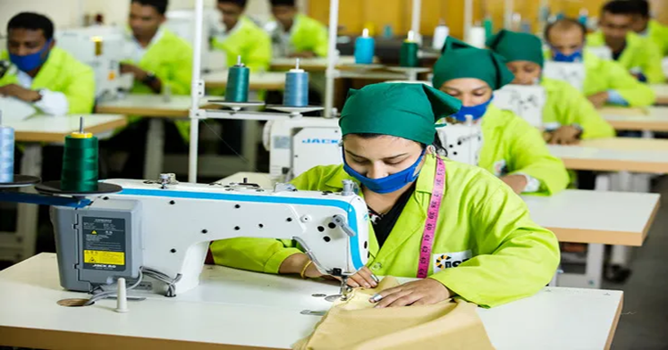

Figure 1: Lady Worker

3.2.1 Image 2:
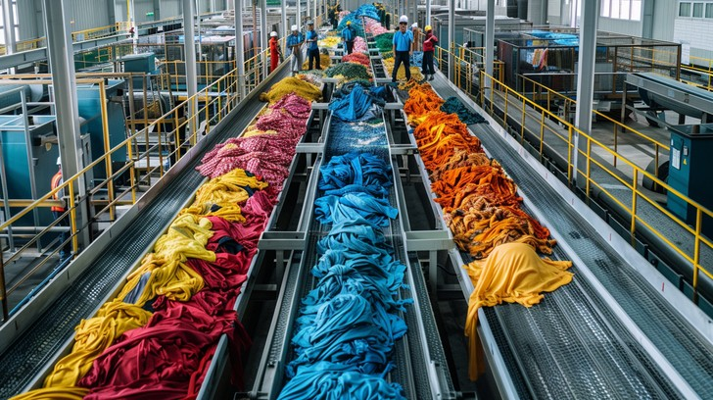

Figure 2: Garment Factory

Chapter 4: Inserting Chart

4.1 Bar Chart (According to table 1)
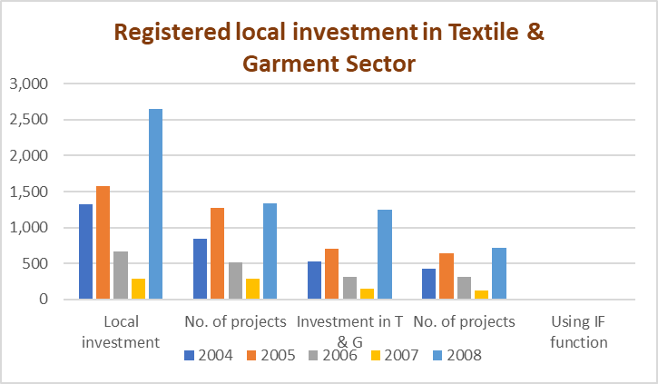

4.2 Line Chart (According to table 2)
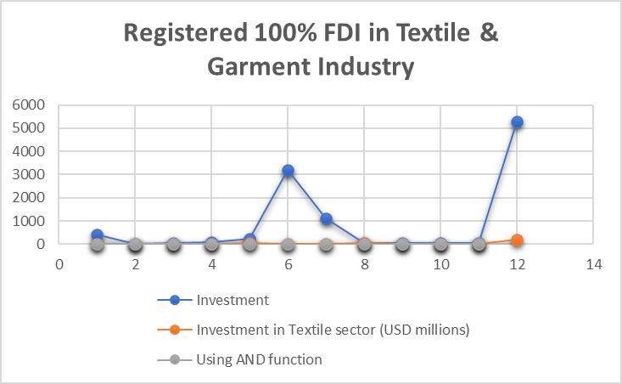

Chapter 5: Process Flow

5.1 Process Flow in a Garment Industry
Merchandising

Sampling

Packing
Pressing & Folding
Fabric & Accessories

Spreading, marker planning and Cutting
Administrative Department
Quality Control

Washing
Sewing

5.2 Market Potential

In Bangladesh, there has been no official attempt to evaluate the impact of textile and garments industries on the other related industries across the value chain, there were some studies and research in 90’s, not well designed. However, it is crystal clear at national and global level that over the years, the industry created additional demand of many products and services. As a result, huge investment has been made in the related industries across the value chain. In brief, Bangladesh experienced a significant number of spinning mills, weaving and knitting mills, dyeing and finishing mills and accessories industries as well as expansion of existing capacity of these related industries. The knitting and hosiery sectors look brighter than weaving, and about ₈₀ percent of garment accessories like cartons, threads, buttons, labels, poly bags, gum tapes, shirt boards and neck boards now are being produced within Bangladesh and contribute to the national gross domestic product through value addition and employment creations.

5.3 Capacity Utilization

Currently, the production capacity of the garment industry in Bangladesh is 50-60% utilized due to crisis in gas and electricity supply at national level as reported by the officials of the enterprises and trade associations. Frequent labor unrest also reduces capacity utilization level. Factories are having adequate export orders, but production is interrupted every 2-3 hours due to power failure and factories remain closed for 1-2 days in 2-3 months due to labor crisis. Spinning and dyeing finishing factories operate in three shifts. However, no official data is available on the capacity utilization. (Verma, 2021)

5.4 Motive Power Required

The power required for this project to run effectively total 60 HP is required to run this unit at installed capacity but our aim is to reduce the energy consumption for base load system and create a sustaining comfortable working condition in the facility. The facility consists mainly of factory area.

Chapter 6: Ideas behind Smart Factory

6.1 Five Critical Ideas behind the Smart Factory

6.2 Quality Control & Standard

The quality of garments mainly depends on quality of fabric used. Therefore, care must be taken while purchasing fabrics to ensure good colorfastness properties, uniformity in shade etc.

SI No. BIS No. Title

1. IS: 4039 Readymade Garment Packing for Export.
2. IS: 10194 Garment Guide for Positioning of Labels.
3. IS: 12675 Garment Quality Guide.

6.3 Pollution Control
The process of manufacture does not generate pollution. However, we have planned to contact State Pollution Control Board for necessary guidance.

Chapter 7: Advantages & Disadvantages

7.1 Advantages of Garment Industry
(1) Job Creation: The garment industry is a major source of employment worldwide, especially in developing countries. It provides work for millions of people, including many women, offering entry-level jobs that often require little formal education.
(2) Economic Growth: The garment sector contributes significantly to the economy, especially in developing countries, through exports and local production. It helps boost the GDP by being one of the top industries for global trade.
(3) Global Trade: Clothing is one of the most traded commodities globally, leading to international business opportunities, collaborations, and supply chains that connect manufacturers with consumers all over the world.
(4) Technological Advancements: The garment industry often drives technological innovation in manufacturing processes. Advancements like automation, 3D printing, and sustainable practices (such as eco-friendly fabrics and dyes) have modernized production and increased efficiency.

7.2 Disadvantages of Garment Industry
1) Exploitation of Labor: A major downside of the garment industry is the exploitation of workers, particularly in developing countries. Low wages, unsafe working conditions, and long hours are common in many factories. This is a critical issue that many organizations are now working to address through ethical production standards.
(2) Environmental Impact: The garment industry is one of the most polluting industries in the world. The production of textiles, particularly fast fashion, leads to massive waste, water pollution, and carbon emissions. Synthetic fibers like polyester are non-biodegradable, and large quantities of water are consumed during dyeing processes.

(3) Fast Fashion Culture: Fast fashion encourages rapid production of cheap clothing to meet trends, often at the cost of quality, ethics, and sustainability. This model leads to wasteful consumption patterns and short product lifecycles, with clothing being discarded quickly.
(4) Health and Safety Risks: In some countries, garment factories operate with poor safety measures, which can lead to accidents, injuries, or even deadly factory collapses, as seen in incidents like the 2013 Rana Plaza disaster in Bangladesh.

Chapter 8: Conclusion

Conclusion on Garments Industry
Bangladeshis are recognized all over the world for their fashion; the fashion statement is not only limited to celebrities but applies for the common masses as well. For the garment industry in Bangladesh, industrialization has proved to be a blessing. Complying with the changing tastes of people and evolving market trends, the garment manufactures in Bangladesh are continuously striving to be innovative. Bangladesh is engaged in heavy export of garments to the international markets.
Today, the buyers of garment segment are aware of the running trends, and demand the newest in fashion and products at a reasonable cost. At the front position of this evolution are the small players, which private labels that are thoroughly transforming the dressing way of men, women and children. With the supply chain limitations eased, organization in real estate markets, and rationale tax structure, the readymade garment segment has become more lucrative and it is anticipated that readymade garment segment will be the main segment in the next five years.

References
- Credé, M., Roch, S. G., & Kieszczynka, U. M. (2010). Why Garment Industry is important? Review of Educational Research, 80(2), 272–295. https://doi.org/10.3102/0034654319358491
- Hershner, S. D., & Chervin, R. D. (2014). Causes and consequences of Garment Industry among different countries. Nature and Science of factory, 6, 73–84. https://doi.org/10.2147/NSS.S62907
- Killgore, W. D. S. (2010). Effects of urbanization on Garment Industry. Progress in Garment Research, 185, 105–129. https://doi.org/10.1016/B978-0-444-53702-6.00008-3
- LeBourgeois, M. L., Hale, L., Chang, A. M., & Montgomery-Downs, H. E. (2017). Digital media and working place in recent Garment factory. Pediatrics, 140(Supplement 2), S78–S81. https://doi.org/10.1542/peds.2016-1758G
- Schmidt, M. (2017). The impact of developing frequent garment industry on environment: A systematic review. Journal of Education and Learning, 6(4), 33–42. https://doi.org/10.5539/jel.v6n4p33
- Walker, M. P. (2017). Why we need garment industry: Unlocking the power of Garment Industry in Bangladesh. Scribner.

__________________________
Mislu



